Please use for each implant a separate sheet.
Please anonymize patient data.

Name
Street
City
Phone
Customer Nr.
Customer/Surgeon

Enclosure Radiographs

Implant:
Name
Article No.
LOT/batch No.

Before Implantation
After Implantation
After Explantation

Incident
 | No Osseointegration |  |  |  | No Primary stability
 | Others

Implant position  (Mark postition please) | 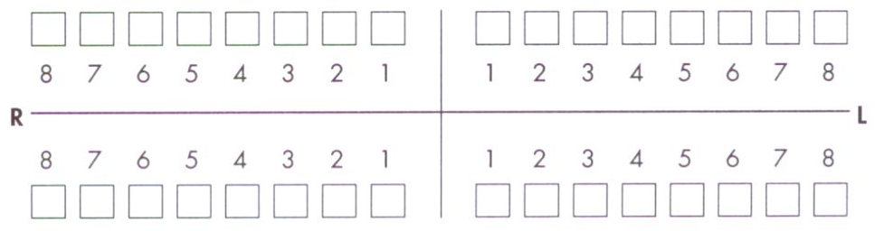

Patient information Patient number______________________

Oral hygiene |  | good |  | ordinary |  | worse
Quality of bone |  | I |  | II |  | III |  | IV
Patient past history |  | Smoker |  | Diabetic |  | Bruxismus

Chewing/bite habit ______________________________

Others ______________________________ ______________________________

Date of Implantation ____________ Prosthesis ______________

 | Yes |  | No
Explantation ____________ Imediate load

Phase of lost/ |  | Healing period |  | Reopening
Of Explantation
 |  | Befor prosthodontic load |  | After prosthodontic load
Augumentation |  | Before OP (two stage) |  | None
 |  | Simultaneous with Implantation

Used materials ____________________________________

Implant bed preparation |  | Ablativ (drill) |  | Bone splitting
 |  | Bone spreading |  | Bone condensing
 |  | Bone taping

Others _______________________________________________

Healing |  | Subgingival |  | Transgingival

Prosthetics |  | Implant borne |  | Combined Implant-/tooth borne
 |  | Single tooth |  | Full denture
 |  | Removable bridge |  | Fixed bridge
 |  | Removable partial denture
 |  | Cemented |  | Screw fixed

Diagnostic before |  | Mobility |  | Horizontal bone loss
Explantation
 |  | Osteolysis around implant |  | Okklusal overload
 |  | Periimplantitis |  | (surrounding) Tissue infection

Others ________________________________________________

Notes _______________________________________________________
_______________________________________________________
Date _______________ Signature ________________________
(In case of pus formation: bact.diagnosis helpful)

